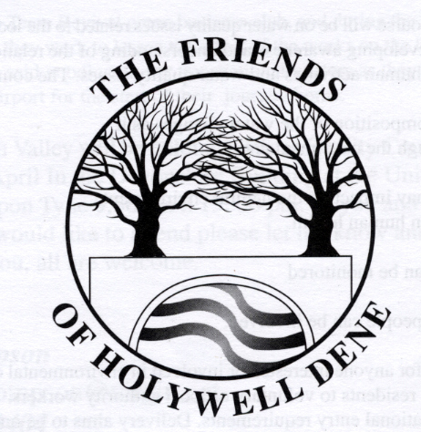

**Do you like searching for things?**

**Do you like finding treasure?**

**Friends of Holywell Dene invite you to a**

**SILVER THEMED TREASURE TRAIL**

**to celebrate 25 years since the group was formed**

* **Come along on 21 June to Hartley Lane car park between 10:30 - 12:30. (Please phone 07958 640903 or email us** [**friendsofholywelldene@gmail.com**](mailto:friendsofholywelldene@gmail.com) **to let us know you’re coming)**
* **Follow the clues**
* **Try to spot the 25 silver-coloured items lurking in the woodland**
* **Free to take part**
* **Approximately 2 kilometres in total**
* **Silver themed treats on completion**
* **Please note, Hartley Lane car park is very small. Park considerately if parking in the estate.**
* **Children under 16 should be accompanied by an adult.**